Support Ticketing System

Project Report

Student Name: Ian Igberaese
Student Number: C00273298
Module: Web & Cloud Application
Lecturer: David Hearne
Submission Date: 20th October 2026

Contents
1. Introduction 2
2. Ticketing System — What It Is and How It Operates 3
2.1 What Is a Support Ticketing System? 3
2.2 How the System Operates 3
2.3 Technologies Used 4
3.Storyboard of Application 4
4. Database Overview 8
4.2 DB.PHP 9
4.3 User Table 9
4.4 Tickets Table 11
4.5 Support Agent Table 14
4.6 Relationship between tables 15
5. Application Function 16
5.1 register.php 17
5.2 loging.php 19
5.3 user_menu.php 21
5.4 open_ticket.php 23
5.5. close_ticket.php 25
5.6 logout.php 27
5.7 agent_login.php 29
5.8 agent_menu.php 31
5.9 search_ticket.php 33
5.10 resolve_ticket.php 36
5.11 elevate_ticket.php 38
6 UX Decisions 41
6.1 Introduction 41
6.2 Navigation and Layout 41
6.3 Forms and Input Validation 42
6.4 Feedback and Ticket Statuses 42
6.6 Responsive Design and Consistency 43
6.7 Overall UX Evaluation 43
7. Conclusion 43

Introduction
This project aimed to design and develop a Support Ticketing System using MySQL, JavaScript and PHP. The project shows how a web application can use client-side processing, server-side processing and a relational database for processing support requests.
The application was developed using docker to keep the environment consistent for development and testing. Docker can run the application and the services it needs in containers. This can make installation easier and make the project available for inspection.
The report explains the purpose and working of the system, provides a story board of the proposed user journey, describes the functions implemented and documents the database structure. To demonstrate the implementation, screenshots and pertinent snippets of code are included.
Docker and Application Setup
Docker was used to run the Support Ticketing System in a containerised environment.
Containers bundle up the services the application needs, such as PHP, a web server and MySQL, so they can run together in a consistent environment. In Docker Compose, these services are configured and managed using a docker-compose.yml file.
The following commands are used to manage and run the application:
- docker compose up -d --build — Builds the required images if necessary and starts the containers in the background.
- docker compose ps — Displays the running containers and their status.
- docker compose logs — Displays the application service logs to help identify errors.
- docker compose down — Stops and removes the containers and networks created by Docker Compose.
- docker compose exec <service> bash — Opens a Bash shell inside a running container, provided Bash is installed.
These commands help start, monitor, troubleshoot and stop the application during development and testing. The exact services and configuration depend on the project's Docker Compose file.

2. Ticketing System — What It Is and How It Operates

2.1 What Is a Support Ticketing System?
A Support Ticketing System is a web application used to record and manage support requests. Each request is represented by a ticket containing information relevant to the issue being reported. The system provides a central location for storing and accessing support information.
The purpose of the application is to organise support requests and make their information easier to manage. The exact functions available depend on the features implemented in the project.

2.2 How the System Operates
The application uses a combination of client-side processing, server-side processing and database operations.
The user interacts with the website through a browser. JavaScript performs any client-side checks implemented in the forms. When information is submitted, PHP receives the request, validates the data and communicates with MySQL when database operations are required.
MySQL stores the information so that it can be retrieved or updated later. The application then returns an appropriate response to the user, such as a confirmation message, displayed information or an error message.
Docker is used to run the services required by the application. This allows the website and database to operate in the configured development environment.

2.3 Technologies Used
- JavaScript: Provides client-side validation and interactive behaviour where implemented.
- PHP: Handles server-side processing, validation and database communication.
- MySQL: Stores the application's data in database tables.
- Docker: Runs the application services in containers and helps maintain a consistent development environment.

3.Storyboard of Application
START
|
v
Open Docker / Terminal
|
v
Navigate to Project Directory
cd C:\Users\C00273298\support_ticketing
|
v
Run the Docker Application
|
v
Home Page (index.php)
|
|---------------------|---------------------|
| | |
v v v
Register User Login Agent Login
| | |
v v v
Enter Full Name, Enter Full Name, Enter Username
Username and Username and and Password
Password Password |
| | |
v v v
Submit Form Submit Login Submit Login
| | |
v v v
Account Created Validate Login Validate Login
| | |
v v v
Registration User Dashboard Agent Dashboard
Complete | |
| | |
v | |
Return to Home | |
| | |
v | |
Choose Login | |
| |
|------------|----------| |------|----------|---------|
| | | | | | |
v v v v v v v
Open Ticket My Tickets Close a Search Open Resolve Elevate
Ticket Ticket Ticket Ticket
| | | | | |
|------------|----------| |----------|---------|
| |
v v
Log Out Log Out
| |
v v
END SESSION END SESSION
The application begins by opening the Support Ticketing System project directory and starting the Docker environment. The user then accesses the home page, implemented in index.php, which provides three options: Register, User Login and Agent Login.
The Register option allows a new user to create an account. The registration form requests the user's full name, username and password. When the completed form is submitted, the application processes the information and creates the account. A confirmation message is displayed to indicate that registration has been completed.
After registration, the user can return to the home page and select the appropriate login option. User Login requires the full name, username and password, while Agent Login requires a username and password.
After successful authentication, users are directed to the user dashboard, where they can open tickets, view their tickets, close a ticket or log out. Agents are directed to the agent dashboard, where they can search open tickets, resolve tickets, elevate tickets or log out.
PHP handles server-side processing and communicates with MySQL through the database connection configured in db.php. The database stores the information required by the registration, login and ticket management functions.
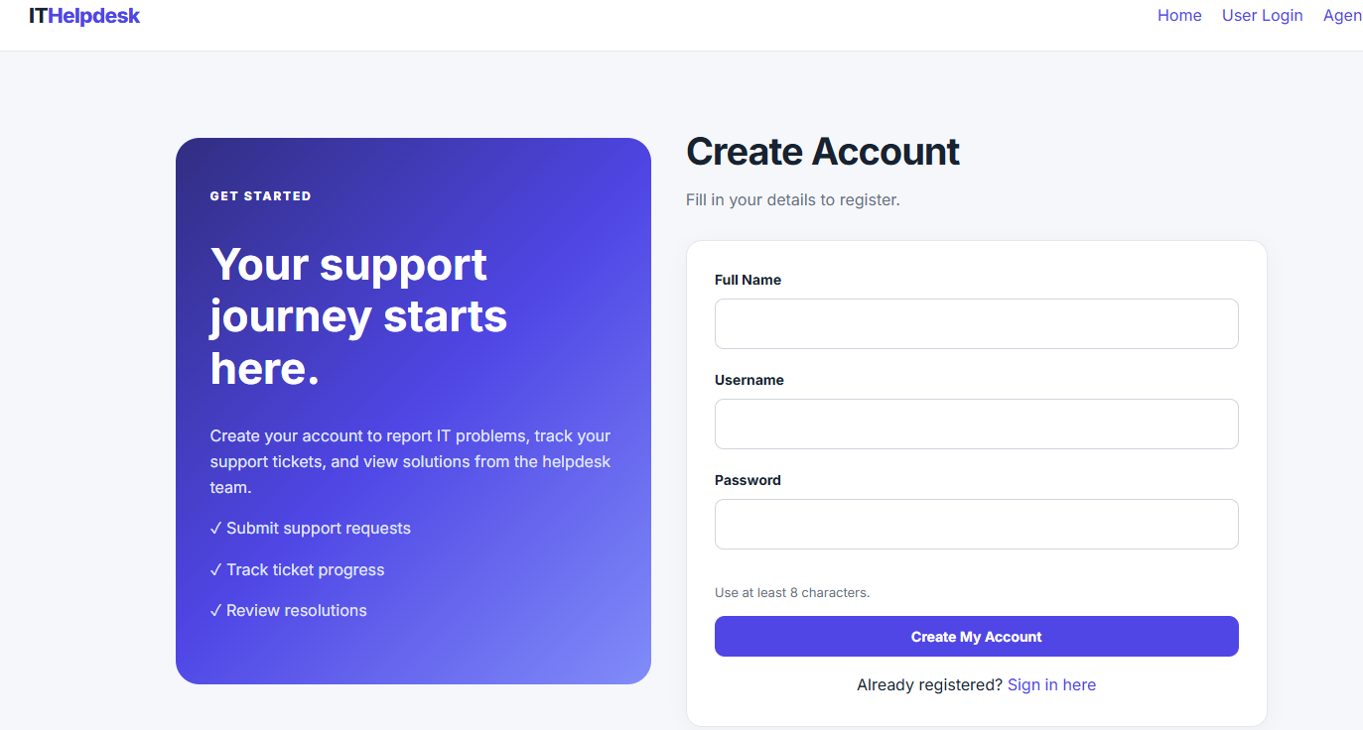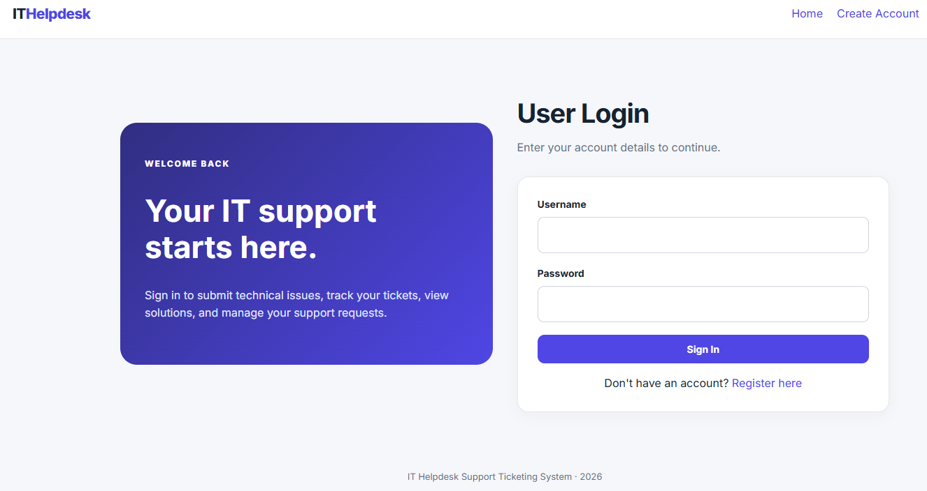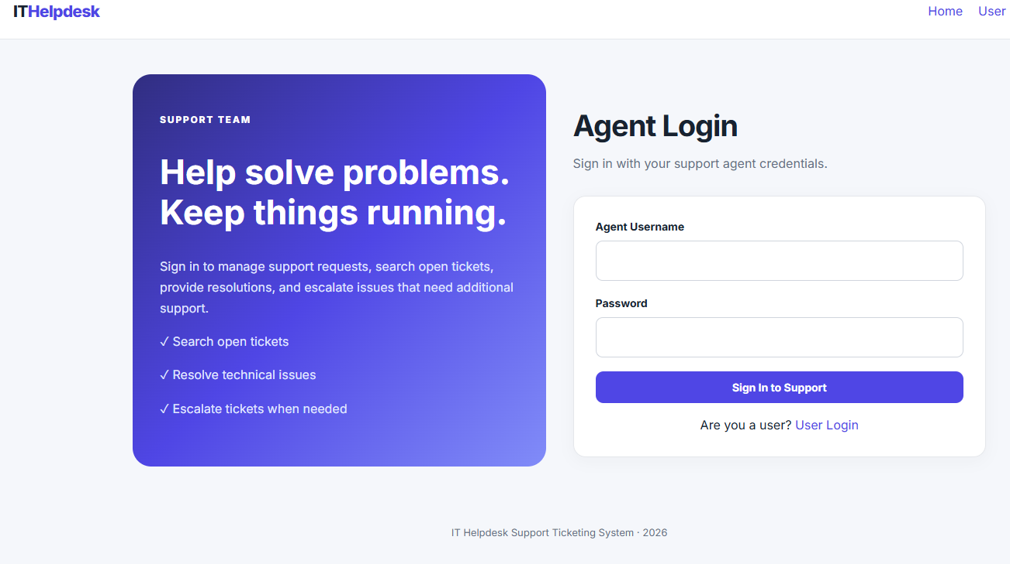

4. Database Overview
The Support Ticketing System uses a MySQL database called support_ticketing to store user account information and support ticket records. The database is an important part of the application because it allows information to be saved and retrieved when required.
The database is used by several functions in the system, including user registration, user login, agent login and ticket management. When a user registers, their account information is stored in the database. When a user opens a ticket, the ticket details are saved so that they can be viewed, closed or managed later.
The database contains a user table and a tickets table, based on the SQL definitions provided. A separate support agent table must be verified against the actual database because the supplied SQL for the agent table duplicates the users table definition.
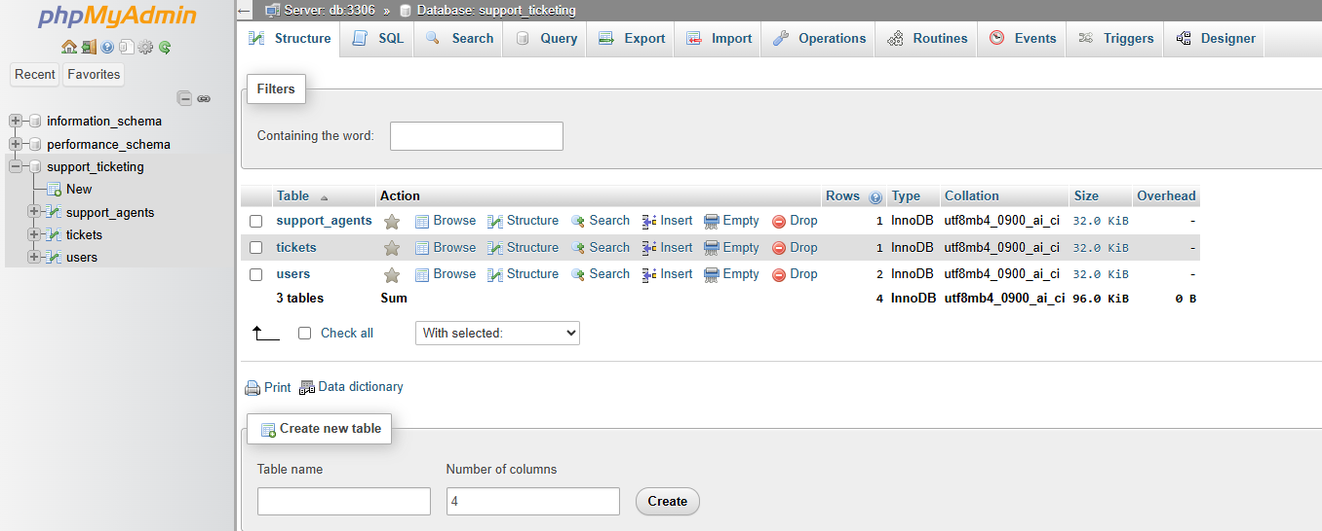

4.2 DB.PHP
The db.php file establishes the connection between the PHP application and the MySQL database. It is required by PHP pages that need to access or modify database information. The file defines four connection settings: the database host, database name, username and password.
In this project, the database name is support_ticketing, and the hostname is db. The hostname refers to the database service on the Docker network rather than necessarily being the address used by the browser.
The connection is created using PDO (PHP Data Objects). PDO provides a way for PHP to communicate with MySQL and execute database queries. The connection settings must match the database configuration. If the hostname, database name, username or password is incorrect, the application may not be able to connect to MySQL. The database container must also be running and reachable from the PHP container. If the connection fails, database-dependent functions such as registration and ticket management will not work correctly.
The file uses a try...catch block to handle connection errors. When a PDO Exception occurs, the detailed error is written to the server log, an HTTP 500 status code is returned, and a general error message is displayed to the user. This prevents detailed database errors from being exposed directly on the web page.

4.3 User Table
The user_id field is the primary key, which gives each user a unique identifier. The username field has a UNIQUE constraint to prevent multiple accounts from using the same username.
The password_hash field is intended to store a hashed password rather than a plain-text password. The created_at field automatically records the date and time at which the account is created.
When a new user completes the registration form, the PHP application processes the submitted details and inserts the account information into this table.
User Table
CREATE TABLE users (
user_id INT AUTO_INCREMENT PRIMARY KEY,
username VARCHAR(50) NOT NULL UNIQUE,
password_hash VARCHAR(255) NOT NULL,
full_name VARCHAR(100) NOT NULL,
created_at TIMESTAMP DEFAULT CURRENT_TIMESTAMP
);
Check whether a username exists — register.php
Before creating an account, the application checks whether the username is already registered.

SELECT user_id
FROM users
WHERE username = ?;
The question mark represents a parameter supplied through a prepared statement.

Register a new user — register.php

INSERT INTO users (username, password_hash, full_name)
VALUES (?, ?, ?);
The PHP code supplies the username, hashed password and full name to create the account.

Retrieve a user account — login.php

SELECT user_id, username, password_hash, full_name
FROM users
WHERE username = ?;
PHP retrieves the account and uses password_verify() to validate the submitted password.
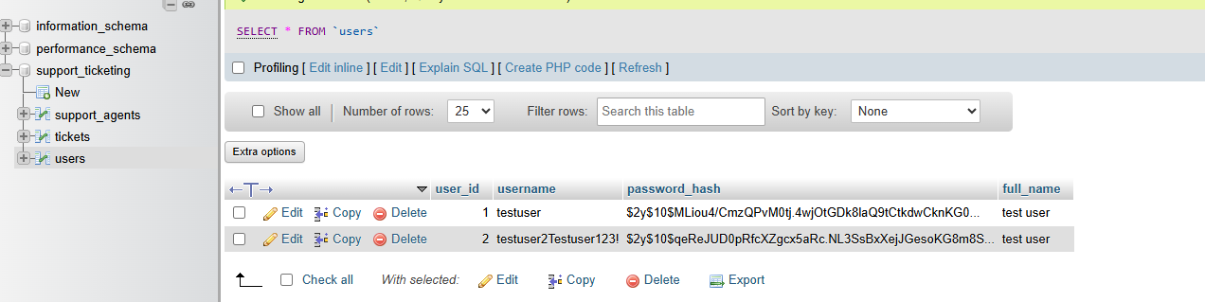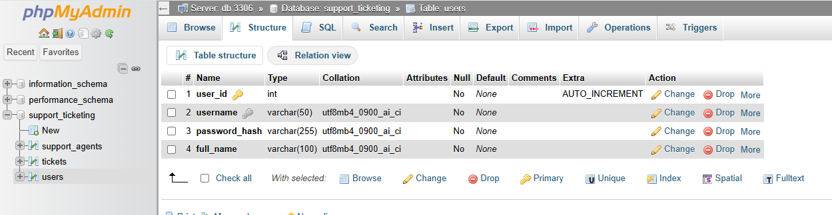

4.4 Tickets Table
The ticket_id field is the primary key for the table. It allows each ticket to be identified separately.
The status field uses the ENUM data type, which restricts the value to Open, Resolved or Closed. New tickets default to Open. This supports the ticket management functions available to users and agents.
The resolution_details field allows information about the resolution to be stored, while elevated_to_level can be used to record an escalation level. Both fields allow NULL values when no information has been recorded.
The table supports the Open Ticket and My Tickets functions used by customers, as well as the Search Open Ticket, Resolve a Ticket and Elevate a Ticket functions available to agents.
CREATE TABLE tickets (
ticket_id INT AUTO_INCREMENT PRIMARY KEY,
user_id INT NOT NULL,
subject VARCHAR(150) NOT NULL,
description TEXT NOT NULL,
status ENUM('Open', 'Resolved', 'Closed')
NOT NULL DEFAULT 'Open',
date_submitted DATETIME NOT NULL DEFAULT CURRENT_TIMESTAMP,
resolution_details TEXT NULL,
elevated_to_level INT NULL,
FOREIGN KEY (user_id) REFERENCES users(user_id)
);
Open a ticket — open_ticket.php
INSERT INTO tickets (
user_id, subject, description,
status, date_submitted
)
VALUES (?, ?, ?, 'Open', NOW());
This query creates a ticket for the logged-in user and sets its status to Open.
View the user's tickets — my_tickets.php
SELECT ticket_id, subject, description,
status, date_submitted, resolution_details
FROM tickets
WHERE user_id = ?
ORDER BY date_submitted DESC;
This retrieves tickets belonging to the logged-in user, displaying the newest tickets first.
Find tickets available to close — close_ticket.php
SELECT ticket_id, subject, status
FROM tickets
WHERE user_id = ?
AND status = 'Resolved'
ORDER BY date_submitted DESC;
This retrieves the user's resolved tickets. A ticket must be resolved before it can be closed through this function.
Close a resolved ticket — close_ticket.php
UPDATE tickets
SET status = 'Closed'
WHERE ticket_id = ?
AND user_id = ?
AND status = 'Resolved';
This updates the status only when the ticket belongs to the user and is already resolved.
Search open tickets — agent function
SELECT ticket_id, user_id, subject,
description, date_submitted
FROM tickets
WHERE status = 'Open'
ORDER BY date_submitted ASC;
This retrieves open tickets, displaying the oldest first so agents can identify outstanding requests.
Resolve a ticket — agent function
UPDATE tickets
SET status = 'Resolved',
resolution_details = ?
WHERE ticket_id = ?
AND status = 'Open';
This marks an open ticket as resolved and records the resolution details.
Elevate a ticket — agent function
UPDATE tickets
SET elevated_to_level = ?
WHERE ticket_id = ?
AND status = 'Open';
This updates the escalation level while keeping the ticket's status as Open.
The PHP application should validate the selected escalation level and check that the agent is authorised to perform the escalation.

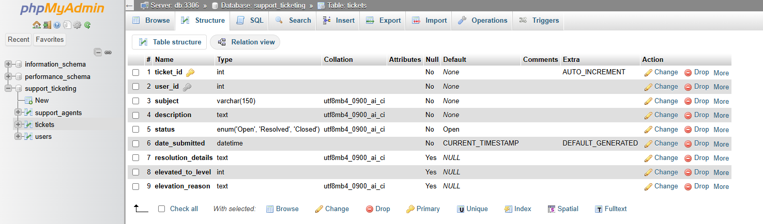

4.5 Support Agent Table
The Support Agent table stores the account information of support agents who use the Support Ticketing System. It contains fields for the agent's unique ID, username, hashed password, full name and account creation date. The user_id field acts as the primary key, ensuring that each agent has a unique identifier. The username field is unique, preventing multiple accounts from using the same username, while password_hash stores the agent's hashed password for authentication.
This table supports the Agent Login function by providing the account information needed to verify an agent's credentials. Once logged in, agents can access functions such as searching for open tickets, resolving tickets and elevating tickets that require further attention. The created_at field automatically records when an account is created, allowing the system to keep track of account creation dates.
The SQL definition you provided earlier creates a table named users, rather than a separate Support Agent table. Check that your actual database contains a separate agent table before including this description in your report.
Support_agent Table
CREATE TABLE users (
user_id INT AUTO_INCREMENT PRIMARY KEY,
username VARCHAR(50) NOT NULL UNIQUE,
password_hash VARCHAR(255) NOT NULL,
full_name VARCHAR(100) NOT NULL,
created_at TIMESTAMP DEFAULT CURRENT_TIMESTAMP
);
Retrieve an agent account — agent_login.php
SELECT agent_id, username, password_hash,
full_name, support_level
FROM support_agents
WHERE username = ?;
The PHP code retrieves the agent's details using the submitted username and verifies the password. Once authenticated, the agent can access functions for searching open tickets, resolving tickets and elevating tickets.

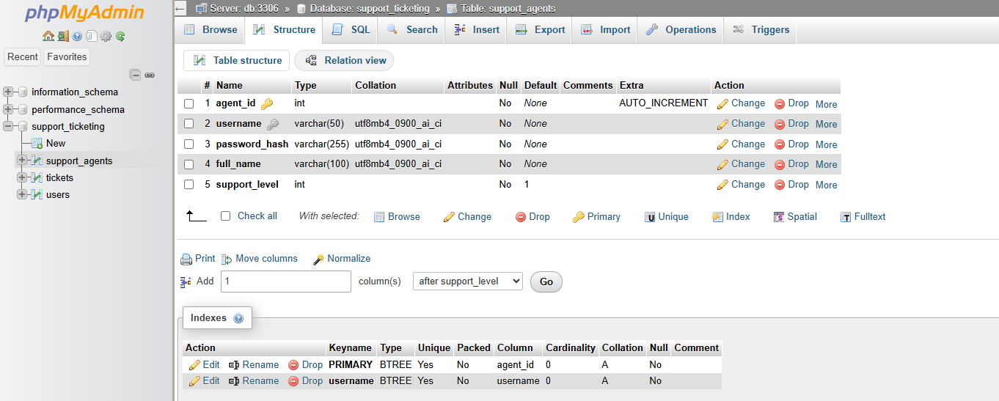

4.6 Relationship between tables
The database uses relationships to connect user accounts with the support tickets they create. The users and tickets tables have a one-to-many relationship, meaning that one registered user can create multiple support tickets, while each ticket is associated with one user.
This relationship is established through the user_id field. In the users table, user_id is the primary key, which uniquely identifies each user. In the tickets table, user_id is a foreign key that references the primary key in the users table. The foreign key helps maintain referential integrity by ensuring that a ticket refers to an existing user.
For example, when a user submits a new support ticket, the application stores the ticket details in the tickets table along with that user's user_id. When the user accesses the My Tickets function, the application uses this ID to retrieve only the tickets associated with their account. This also allows the system to distinguish between tickets submitted by different users.
The relationship is defined in the SQL code as follows:
sql
FOREIGN KEY (user_id) REFERENCES users(user_id)
This statement connects the user_id field in the tickets table to the user_id field in the users table. It helps prevent tickets from referencing users who do not exist in the database.
The support_agents table serves a different purpose. It stores agent account details and is used by agent_login.php to authenticate support agents. Based on the SQL queries provided, the agent table is not directly linked to the tickets table because there is no agent_id foreign key in the ticket structure. Agents can search, resolve and elevate tickets through the application, but the current table design does not directly record which agent handled each ticket.
Overall, these relationships allow the database to organise information efficiently, connect support requests to the users who created them and support the main functions of the Support Ticketing System.

5. Application Function
Compose.yaml
services:
web:
image: php:8.3-apache
ports:
- "8080:80"
volumes:
- ./:/var/www/html
depends_on:
- db
command: >
bash -c "docker-php-ext-install pdo_mysql && apache2-foreground"

db:
image: mysql:8.0
environment:
MYSQL_DATABASE: support_ticketing
MYSQL_USER: ticketuser
MYSQL_PASSWORD: ticketpass123
MYSQL_ROOT_PASSWORD: localroot123
ports:
- "3307:3306"
volumes:
- db_data:/var/lib/mysql

phpmyadmin:
image: phpmyadmin:latest
ports:
- "8081:80"
environment:
PMA_HOST: db
PMA_PORT: 3306
depends_on:
- db

volumes:
db_data:

5.1 register.php
The registration function allows new users to create an account for the IT Helpdesk Support Ticketing System. The user must enter their full name, username and password. The form checks that all fields are completed, the full name is no longer than 100 characters, the username is no longer than 50 characters and the password and contains at least eight characters.
JavaScript performs basic client-side validation before the form is submitted. PHP then validates the information on the server, checks whether the username already exists in the MySQL database and creates the account if the information is valid. The password is hashed using PHP's password_hash() function before it is stored in the users table.
If the username is already taken or the information is invalid, an error message is displayed. When registration is successful, a confirmation message appears with a link to the User Login page.
Client-Side JavaScript
The JavaScript checks that the full name and username are not empty and that the password contains at least eight characters. If the information is invalid, it prevents form submission and displays an alert message.
document.getElementById('registerForm')?.addEventListener('submit', function(event) {
const fullName = document.getElementById('full_name').value.trim();
const username = document.getElementById('username').value.trim();
const password = document.getElementById('password').value;

if (!fullName || !username || password.length < 8) {
event.preventDefault();
alert('Enter your full name, username, and a password of at least 8 characters.');
}
});
This provides immediate feedback to users before the form is processed by the server. However, server-side validation is still required because client-side JavaScript can be bypassed.
Server-Side PHP Code
The PHP code first includes db.php to connect to the MySQL database. It then checks whether the form has been submitted using the POST method and retrieves the submitted values.
The following code validates the fields and checks whether the username already exists.
if ($_SERVER['REQUEST_METHOD'] === 'POST') {
$fullName = trim($_POST['full_name'] ?? '');
$username = trim($_POST['username'] ?? '');
$password = $_POST['password'] ?? '';

if ($fullName === '' || $username === '' || $password === '') {
$error = 'Please complete every field.';
} elseif (
strlen($username) > 50 ||
strlen($password) < 8 ||
strlen($fullName) > 100
) {
$error = 'Your details do not meet the required limits.';
} else {
$check = $pdo->prepare(
'SELECT user_id FROM users WHERE username = ?'
);
$check->execute([$username]);

if ($check->fetch()) {
$error = 'That username is already taken. Please choose another.';
}
}
}
If the username is available, the password is hashed and the new account is inserted into the database.
$hash = password_hash($password, PASSWORD_DEFAULT);
$stmt = $pdo->prepare(
'INSERT INTO users (username, password_hash, full_name)
VALUES (?, ?, ?)'
);
$stmt->execute([$username, $hash, $fullName]);
$success = 'Registration successful! Your account is ready.';

Prepared statements are used to safely pass user input into SQL queries. The password hash is stored instead of the original password, improving account security. 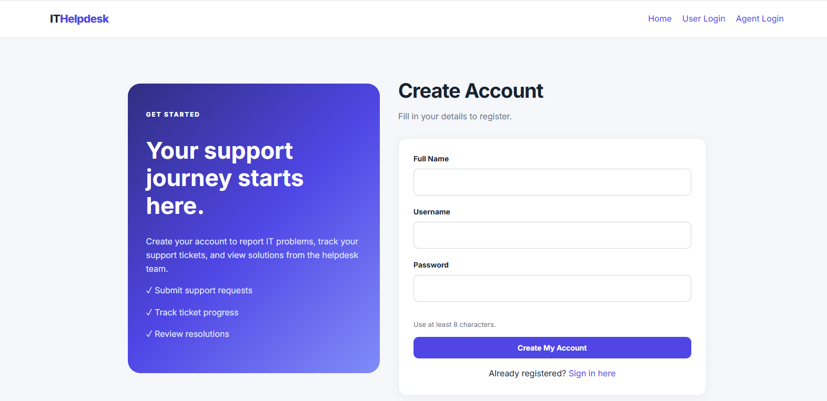

5.2 loging.php
The User Login function allows registered users to access the Support Ticketing System by entering their username and password. JavaScript checks that both fields have been completed before the form is submitted.
The PHP code retrieves the user's account from the MySQL users table and verifies the entered password against the stored password hash using password_verify(). If the credentials are correct, a session is created containing the user's ID, username, full name and role. The session ID is regenerated for security, and the user is redirected to user_menu.php, where they can access the ticketing functions.
If the username or password is incorrect, an error message is displayed asking the user to try again.
Client-Side JavaScript
The JavaScript checks that the username and password fields are not empty. If either field is empty, the form submission is prevented and an alert is displayed.
document.getElementById('loginForm').addEventListener('submit', function(event) {
const username = document.getElementById('username').value.trim();
const password = document.getElementById('password').value;

if (!username || !password) {
event.preventDefault();
alert('Please enter your username and password.');
}
});
This provides immediate feedback and helps prevent incomplete form submissions. However, PHP must still verify the login details on the server because JavaScript validation can be bypassed.
Server-Side PHP Code
The PHP code starts a session and connects to the database using db.php. It then retrieves the account matching the submitted username.
session_start();
require_once 'db.php';

$stmt = $pdo->prepare(
'SELECT user_id, username, password_hash, full_name
FROM users
WHERE username = ?'
);
$stmt->execute([$username]);
$user = $stmt->fetch();
A prepared statement is used to safely pass the username into the SQL query.
The following code verifies the password and establishes the user's session if authentication succeeds.
if ($user && password_verify($password, $user['password_hash'])) {
session_regenerate_id(true);

$_SESSION['user_id'] = $user['user_id'];
$_SESSION['username'] = $user['username'];
$_SESSION['full_name'] = $user['full_name'];
$_SESSION['role'] = 'user';

header('Location: user_menu.php');
exit;
} else {
$error = 'Invalid username or password.';
}

The password_verify() function compares the entered password with the stored hash. session_regenerate_id(true) regenerates the session ID after successful authentication. The session variables allow other PHP pages to identify the logged-in user and determine their role.
If authentication fails, the system displays a general error message without revealing whether the username or password was incorrect. 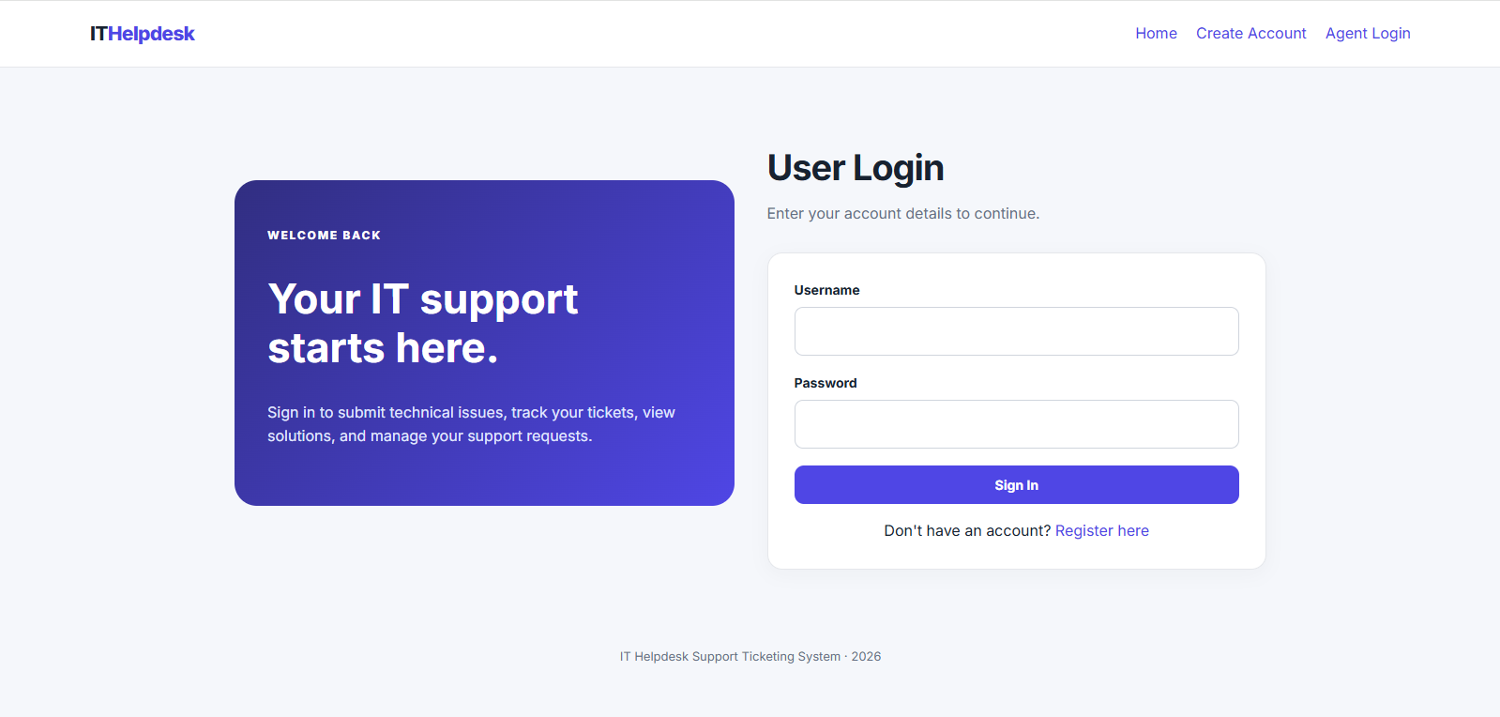

5.3 user_menu.php
The User Dashboard is the main page users see after successfully logging in to the Support Ticketing System. It provides a central location from which users can manage their support requests.
The dashboard contains three main functions: Open a Ticket, My Tickets and Close a Ticket. Users can submit new IT problems, view existing tickets and check their status and resolution details. They can also close tickets that have been resolved by a support agent.
The dashboard displays a personalised welcome message using the user's full name stored in the session. It also explains the three ticket statuses: Open, Resolved and Closed, helping users understand the progress of their support requests.
The page uses PHP sessions to restrict access to authenticated users. If a user is not logged in or does not have the correct user role, they are redirected to the User Login page. This helps prevent unauthorised access to the dashboard.
Server-Side PHP Code
The following code checks whether the user is authenticated before allowing access to the dashboard.
session_start();

if (
!isset($_SESSION['user_id']) ||
($_SESSION['role'] ?? '') !== 'user'
) {
header('Location: login.php');
exit;
}
The session_start() function allows PHP to access the session information created during login. The code checks that a user ID exists and that the session role is set to user. If either condition fails, the visitor is redirected to the login page.
The following code retrieves the user's full name from the session and escapes it before displaying it on the webpage.
$name = htmlspecialchars(
$_SESSION['full_name'] ?? 'User',
ENT_QUOTES,
'UTF-8'
);
This allows the dashboard to display a personalised greeting while helping prevent user-provided text from being interpreted as HTML.
Dashboard Navigation
The dashboard uses links to direct users to the relevant PHP pages:
- Open a Ticket: Opens open_ticket.php to submit a new support request.
- My Tickets: Opens my_tickets.php to view existing tickets and their statuses.
- Close a Ticket: Opens close_ticket.php to close a resolved ticket.
- Logout: Opens logout.php to end the user's session.
These links connect the dashboard to the other functions of the application. The page also includes a status guide explaining what Open, Resolved and Closed mean.
Client-Side Processing
No JavaScript is used on this page. The navigation is handled using standard links, while PHP manages session verification and personalises the welcome message.
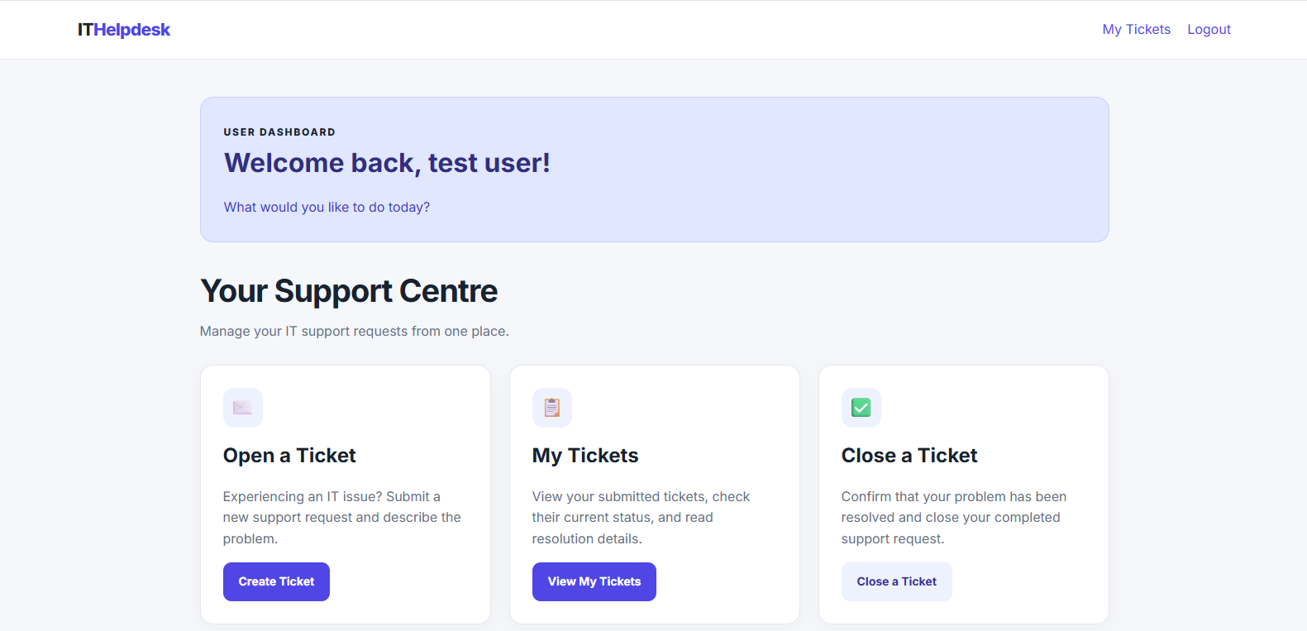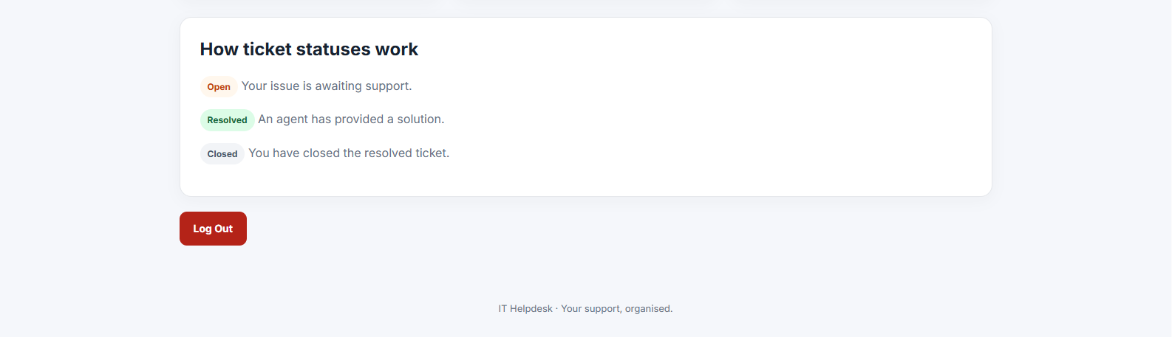

5.4 open_ticket.php
The Open a Ticket function allows logged-in users to submit a new IT support request. Users enter a subject describing their issue and provide a detailed description of the problem. The page also provides guidance on writing a clear ticket so the support team can understand the issue.
Before processing the request, PHP checks that the user is logged in with the correct role. It then validates the submitted information, ensuring both fields are completed and that the subject does not exceed 150 characters.
If the information is valid, PHP uses a prepared SQL statement to insert the ticket into the MySQL tickets table. The ticket is associated with the logged-in user's ID and is automatically assigned the status Open. The submission date and time are recorded using NOW().
After successful submission, a confirmation message appears, with links to view existing tickets, submit another ticket or return to the dashboard. If the information is invalid, an error message is displayed.
Client-Side JavaScript
The JavaScript checks that the subject and description contain text before the form is submitted. If either field is empty, the form submission is prevented and an alert message is displayed.
document.getElementById('ticketForm').addEventListener('submit', function(event) {
const subject = document.getElementById('subject').value.trim();
const description = document.getElementById('description').value.trim();

if (!subject || !description) {
event.preventDefault();
alert('Please enter a subject and describe your problem.');
}
});
This provides immediate feedback and helps users avoid submitting incomplete tickets. PHP also performs server-side validation because JavaScript checks can be bypassed.
Server-Side PHP Code
The page starts a session, connects to the database and checks that the user is logged in with the correct role.
session_start();
require_once 'db.php';

if (!isset($_SESSION['user_id']) || ($_SESSION['role'] ?? '') !== 'user') {
header('Location: login.php');
exit;
}
The following code validates the subject and description before inserting the ticket into the database.
$subject = trim($_POST['subject'] ?? '');
$description = trim($_POST['description'] ?? '');

if ($subject === '' || $description === '') {
$error = 'Please complete both fields.';
} elseif (strlen($subject) > 150) {
$error = 'The subject must be 150 characters or fewer.';
} else {
$stmt = $pdo->prepare(
"INSERT INTO tickets
(user_id, subject, description, status, date_submitted)
VALUES (?, ?, ?, 'Open', NOW())"
);

$stmt->execute([
$_SESSION['user_id'],
$subject,
$description
]);

$success = 'Your ticket has been submitted successfully.';
}
The prepared statement inserts the user's ID, ticket subject and description into the tickets table. The status is set to Open, and the current date and time are recorded. Using the session's user ID ensures the ticket is associated with the logged-in account rather than relying on a user ID submitted through the form. 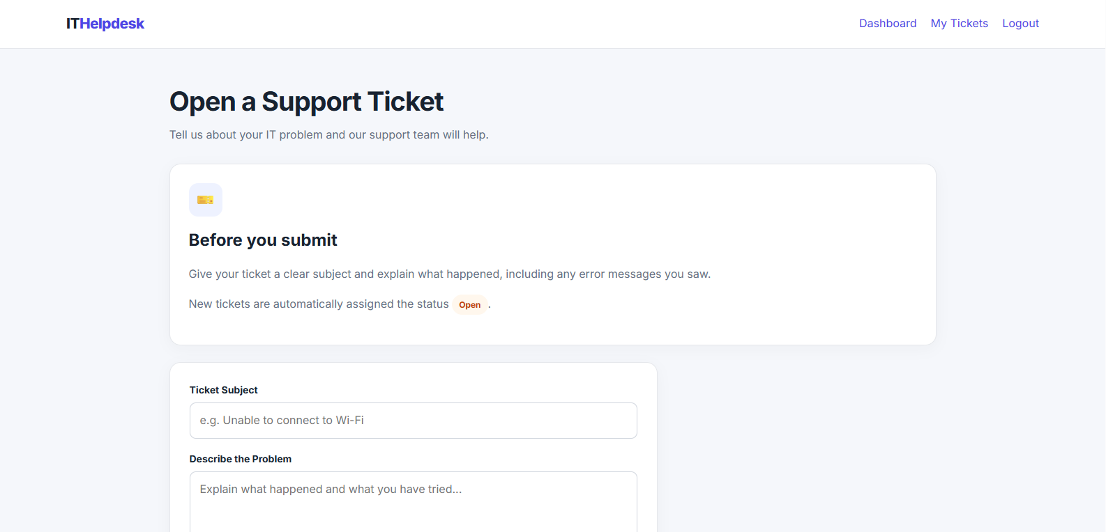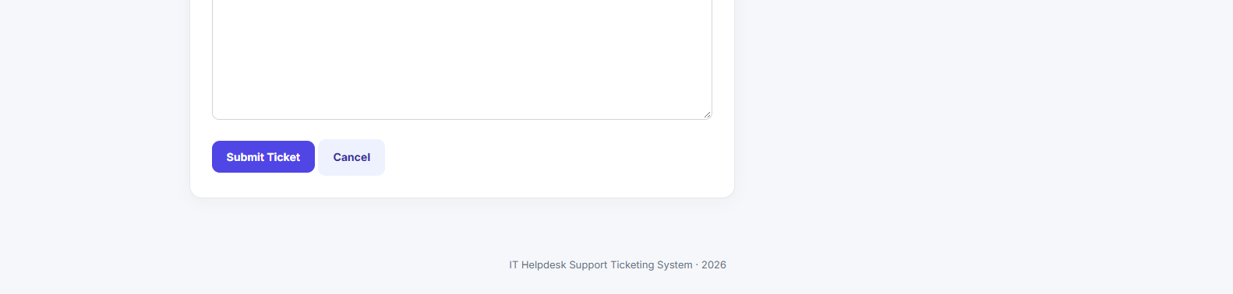

5.5. close_ticket.php
The Close a Ticket function allows users to close a support ticket after a support agent has marked it as resolved. This ensures that tickets are not closed before a solution has been provided.
When the page loads, PHP checks that the user is logged in and has the correct user role. It then retrieves the user's resolved tickets from the MySQL database and displays them in a dropdown list. Each option shows the ticket ID and subject, allowing the user to select the appropriate ticket.
When the user selects a ticket and clicks the Close Selected Ticket button, JavaScript displays a confirmation message to prevent accidental closure. If the user confirms, the form is submitted to PHP, which validates the ticket ID and updates the ticket's status from Resolved to Closed.
The SQL query checks that the selected ticket belongs to the logged-in user and is currently resolved. This prevents users from closing another user's ticket or closing a ticket that has not yet been resolved. A success or error message is displayed depending on the result. If the user has no resolved tickets, the page explains that a support agent must resolve a ticket before it can be closed.
Client-Side JavaScript
The JavaScript displays a confirmation prompt before the selected ticket is closed. If the user cancels, the form submission is prevented.
document.getElementById('closeTicketForm').addEventListener('submit', function(event) {
if (!confirm('Are you sure you want to close this resolved ticket?')) {
event.preventDefault();
}
});
This provides an additional usability feature by reducing the risk of users closing tickets accidentally. However, the confirmation is not a security check; PHP still validates the request on the server.
Server-Side PHP Code
The page starts a session, connects to the database and checks that the visitor is an authenticated user.
session_start();
require_once 'db.php';

if (!isset($_SESSION['user_id']) || ($_SESSION['role'] ?? '') !== 'user') {
header('Location: login.php');
exit;
}
The following code retrieves resolved tickets belonging to the logged-in user.
$stmt = $pdo->prepare(
"SELECT ticket_id, subject, status
FROM tickets
WHERE user_id = ? AND status = 'Resolved'
ORDER BY date_submitted DESC"
);
$stmt->execute([$_SESSION['user_id']]);
$tickets = $stmt->fetchAll();
The query uses the session's user ID to ensure that only the current user's resolved tickets are displayed. The tickets are ordered by submission date, with the newest first.
When the user submits the form, PHP validates the ticket ID and updates the status if the ticket meets the required conditions.
$ticketId = filter_input(INPUT_POST, 'ticket_id', FILTER_VALIDATE_INT);

if ($ticketId) {
$stmt = $pdo->prepare(
"UPDATE tickets
SET status = 'Closed'
WHERE ticket_id = ?
AND user_id = ?
AND status = 'Resolved'"
);

$stmt->execute([$ticketId, $_SESSION['user_id']]);

if ($stmt->rowCount() > 0) {
$message = 'Your ticket has been closed successfully.';
} else {
$message = 'The ticket was not found or has not been resolved yet.';
$messageType = 'message error';
}
}
The prepared statement safely passes the ticket ID and user ID into the SQL query. The conditions ensure that only a resolved ticket belonging to the logged-in user can be closed. The rowCount() method checks whether a database row was updated, allowing PHP to display an appropriate result message. 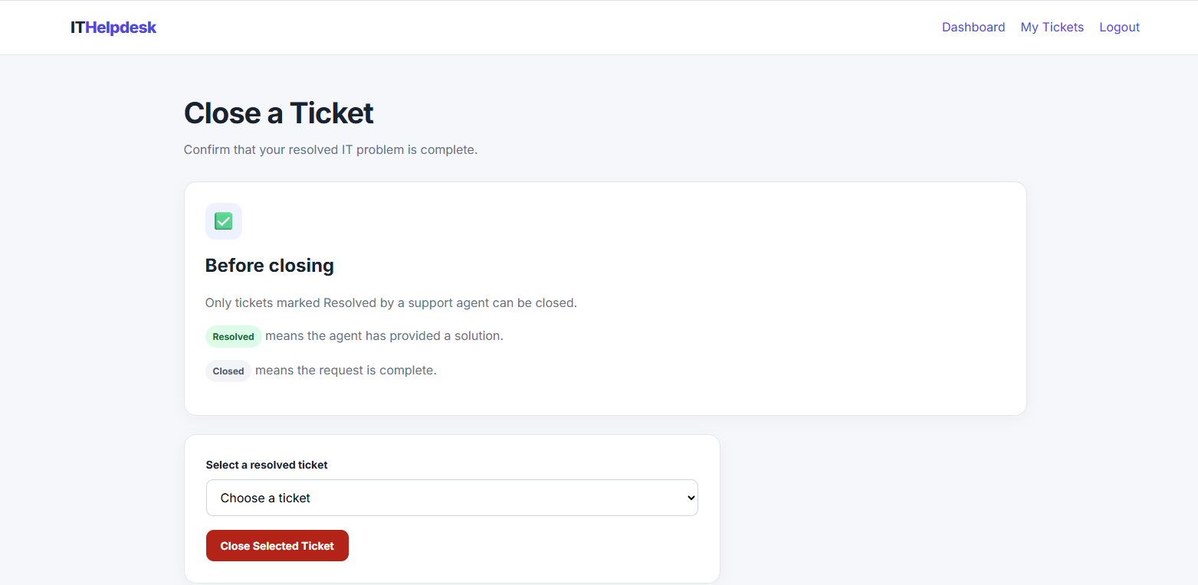

5.6 logout.php
Function Description
The Logout function allows users and support agents to securely leave the Support Ticketing System. It prevents the session from remaining active after the user has finished using the application.
When the logout link is selected, PHP starts the session and clears the session variables containing information about the logged-in user. It then removes the session cookie from the browser, if cookies are being used, and destroys the session on the server.
Finally, the user is redirected to the homepage, index.php. This allows another user to access the system or the previous user to log in again when required.
The logout function is important for security, particularly when the system is accessed on a shared computer. It helps prevent another person from using the previous user's active session.
Server-Side PHP Code
The following code starts the session and clears its stored variables.
session_start();

// Clear the logged-in user's session.
$_SESSION = [];
The next section removes the session cookie from the browser, if PHP is configured to use cookies for session management.
if (ini_get('session.use_cookies')) {
$params = session_get_cookie_params();

setcookie(
session_name(),
'',
time() - 42000,
$params['path'],
$params['domain'],
$params['secure'],
$params['httponly']
);
}
The cookie's expiry time is set in the past so that the browser removes it. The existing cookie parameters are retained when setting the expired cookie.
The final section destroys the session and redirects the user to the homepage.
session_destroy();

header('Location: index.php');
exit;
The session_destroy() function removes the server-side session data. The header() function redirects the browser to index.php, and exit stops further PHP processing.
Client-Side Processing
No JavaScript is required for this function. Logout is handled entirely by PHP on the server, while the browser follows the redirect to the homepage.

5.7 agent_login.php
The Agent Login function allows authorised support agents to access the agent area of the IT Helpdesk Support Ticketing System. Agents must enter their username and password to authenticate themselves.
The page uses JavaScript to check that both fields have been completed before the form is submitted. PHP then retrieves the agent's account details from the MySQL support_agents table using the submitted username. The entered password is verified against the stored password hash using PHP's password_verify() function.
If the credentials are correct, PHP regenerates the session ID and stores the agent's ID, username, full name, support level and role in the session. The agent is then redirected to agent_menu.php, where they can access functions for searching open tickets, resolving issues and elevating tickets that require additional support.
If the credentials are incorrect, an error message is displayed. The page does not reveal whether the username or password was incorrect, helping avoid disclosing unnecessary account information.
Client-Side JavaScript
The JavaScript checks that the agent has entered both a username and a password. If either field is empty, it prevents the form from being submitted and displays an alert.
document.getElementById('agentLoginForm').addEventListener('submit', function(event) {
const username = document.getElementById('username').value.trim();
const password = document.getElementById('password').value;

if (!username || !password) {
event.preventDefault();
alert('Please enter your agent username and password.');
}
});
This improves usability by identifying incomplete form submissions before they reach the server. However, PHP must still perform authentication because client-side validation can be bypassed.
Server-Side PHP Code
The PHP code starts the session, connects to the database and prepares an SQL query to retrieve the agent account matching the submitted username.
session_start();
require_once 'db.php';

$stmt = $pdo->prepare(
'SELECT agent_id, username, password_hash, full_name, support_level
FROM support_agents
WHERE username = ?'
);
$stmt->execute([$username]);
$agent = $stmt->fetch();
The prepared statement retrieves the agent's account details from the support_agents table. Using a prepared statement helps protect the query from SQL injection.
The following code verifies the password and creates the agent's session if authentication succeeds.
if ($agent && password_verify($password, $agent['password_hash'])) {
session_regenerate_id(true);

$_SESSION['agent_id'] = $agent['agent_id'];
$_SESSION['username'] = $agent['username'];
$_SESSION['full_name'] = $agent['full_name'];
$_SESSION['support_level'] = $agent['support_level'];
$_SESSION['role'] = 'agent';

header('Location: agent_menu.php');
exit;
} else {
$error = 'Invalid agent username or password.';
}
The password_verify() function compares the submitted password with the stored hash. When the credentials are correct, the session stores the agent's details and role. The support_level value can be used by other application functions when managing ticket escalation.
The agent is redirected to agent_menu.php after successful authentication. If authentication fails, the system displays an error message instead. 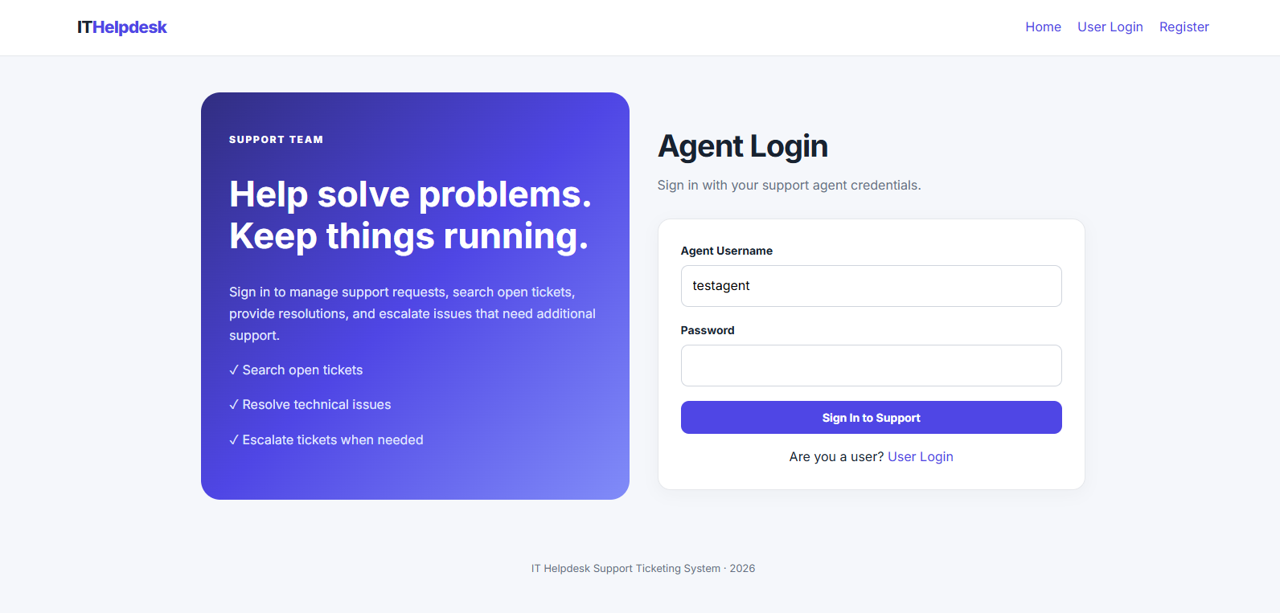

5.8 agent_menu.php
Function Description
The Agent Dashboard is the main page displayed after a support agent successfully logs in to the IT Helpdesk Support Ticketing System. It provides a central location for managing support requests and accessing the agent functions.
The dashboard displays a personalised welcome message using the agent's full name and shows their support level. It provides three main functions: Search Open Tickets, Resolve a Ticket and Elevate a Ticket.
The Search Open Tickets function allows agents to find open support requests and review the problems reported by users. The Resolve a Ticket function allows agents to provide a solution and update a ticket's status to Resolved. The Elevate a Ticket function allows agents to escalate issues to a higher support level when additional expertise is required.
The dashboard also displays a support workflow guide explaining the meanings of the Open, Resolved and Closed statuses. Navigation links allow agents to return to the dashboard, search tickets, visit the main homepage or log out.
Server-Side PHP Code
The PHP code starts the session and checks that the visitor is an authenticated support agent before allowing access to the dashboard.
session_start();

if (
!isset($_SESSION['agent_id']) ||
($_SESSION['role'] ?? '') !== 'agent'
) {
header('Location: agent_login.php');
exit;
}
The code checks that an agent ID exists in the session and that the session role is agent. If these conditions are not met, the visitor is redirected to the Agent Login page. This helps prevent ordinary users and unauthenticated visitors from accessing the agent dashboard.
The following code retrieves the agent's name and support level from the session.
$name = htmlspecialchars(
$_SESSION['full_name'] ?? 'Support Agent',
ENT_QUOTES,
'UTF-8'
);

$supportLevel = (int) ($_SESSION['support_level'] ?? 1);
The htmlspecialchars() function helps prevent the agent's name from being interpreted as HTML when displayed. The support level is converted to an integer before it is shown on the page.
Dashboard Navigation
The dashboard uses links to connect the agent to the main ticket management functions:
- Search Open Tickets: Opens search_tickets.php to find and review open support requests.
- Resolve a Ticket: Opens resolve_ticket.php to record a solution and resolve an issue.
- Elevate a Ticket: Opens elevate_ticket.php to escalate an issue to a higher support level.
- Logout: Opens logout.php to end the current session.
- Main Homepage: Returns to index.php.
These links provide a straightforward way for agents to move between the different functions without needing to enter page addresses manually.
Client-Side Processing
No JavaScript is used on this page. Navigation is handled through standard links, while PHP manages session verification and displays the agent's information dynamically. 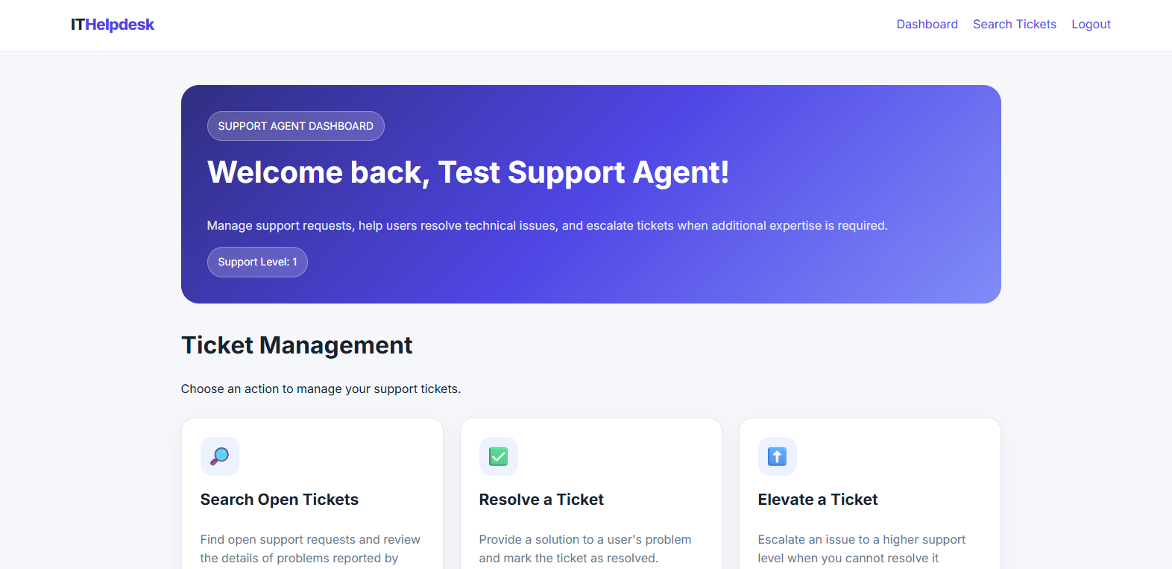 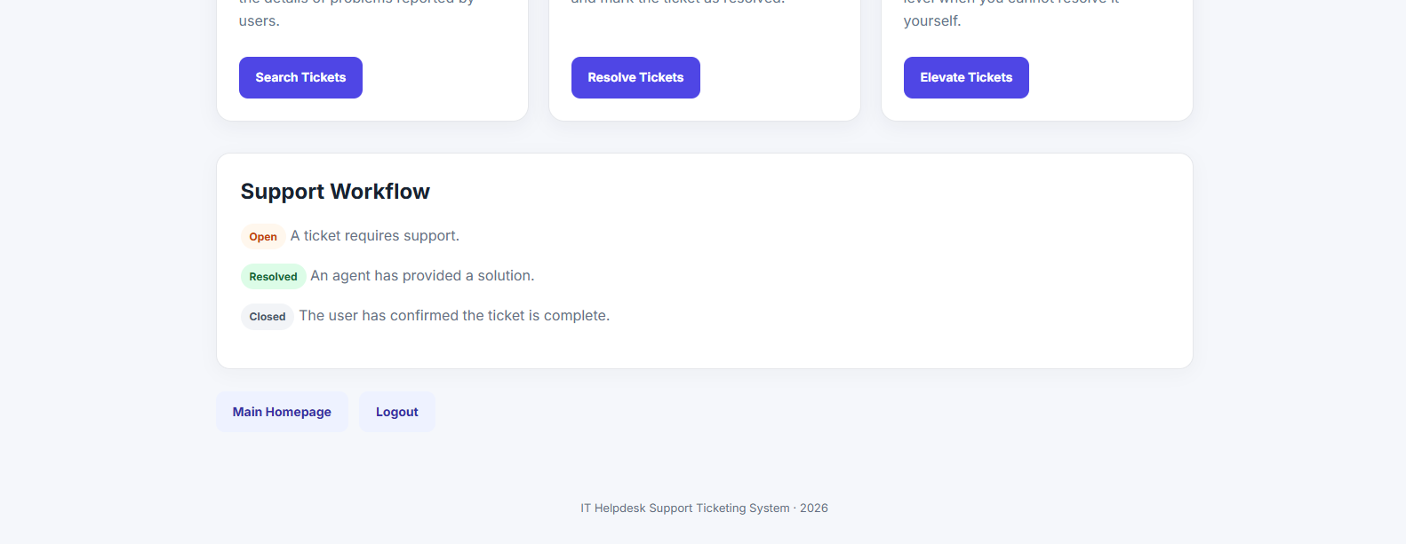

5.9 search_ticket.php
The Search Open Tickets function allows support agents to find and review support requests that still require attention. Agents can search using a ticket's subject, description, the user's full name or username.
When the page loads, PHP checks that the visitor is logged in as a support agent. It then retrieves all tickets with the status Open from the MySQL database. The query joins the tickets and users tables so that the agent can see both the problem details and the information of the user who submitted the ticket.
When a search term is entered, the application filters the results using the SQL LIKE operator. This allows partial matches, making it easier to find relevant tickets without entering the complete subject or username. The results are ordered by submission date, with the oldest tickets displayed first.
The page displays the ticket ID, subject, description, submitting user's name and username, submission date and current status. If no matching tickets are found, a message is displayed. Agents can also select Show All Open to remove the search filter and view all open tickets.
Client-Side Processing
No custom JavaScript is used on this page. The search form uses the HTTP GET method to send the search term to search_tickets.php. The search term appears in the URL, allowing the search to be repeated or bookmarked. The page is then processed by PHP to retrieve the matching results.
Server-Side PHP Code
The following code checks that the visitor is an authenticated support agent before allowing access to the page.
session_start();
require_once 'db.php';

if (
!isset($_SESSION['agent_id']) ||
($_SESSION['role'] ?? '') !== 'agent'
) {
header('Location: agent_login.php');
exit;
}
The search term is then retrieved from the URL and trimmed to remove unnecessary whitespace.
$search = trim($_GET['search'] ?? '');
The following SQL query retrieves open tickets and joins the users table to obtain the details of the person who submitted each ticket.
SELECT
t.ticket_id,
t.subject,
t.description,
t.status,
t.date_submitted,
u.full_name AS user_name,
u.username AS user_username
FROM tickets t
JOIN users u ON t.user_id = u.user_id
WHERE t.status = 'Open'
If a search term is provided, PHP adds conditions to search the subject, description, full name and username.
if ($search !== '') {
$sql .= "
AND (
t.subject LIKE ?
OR t.description LIKE ?
OR u.username LIKE ?
OR u.full_name LIKE ?
)
";

$term = '%' . $search . '%';
$params = [$term, $term, $term, $term];
}

$sql .= " ORDER BY t.date_submitted ASC";

$stmt = $pdo->prepare($sql);
$stmt->execute($params);
$tickets = $stmt->fetchAll();

The percentage signs around the search term allow partial matches. Prepared statements safely pass the search values into the query. The results are retrieved using fetchAll() and displayed in a table.
The page also uses htmlspecialchars() through the escapeHtml() function to escape displayed text. This helps prevent user-submitted ticket content from being interpreted as HTML. 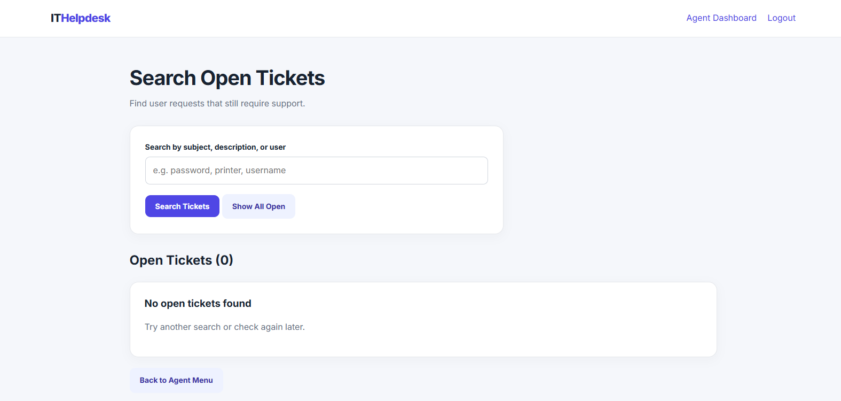

5.10 resolve_ticket.php
The Resolve a Ticket function allows support agents to record a solution to a user's IT problem and update the ticket's status from Open to Resolved.
When the page loads, PHP checks that the visitor is logged in as a support agent. It then retrieves all tickets that still have an Open status from the MySQL database, displaying them in a selection list. The agent selects the ticket they want to resolve and enters details describing the solution provided.
When the form is submitted, PHP validates that a ticket has been selected and that resolution details have been entered. A prepared SQL statement then updates the selected ticket's status to Resolved and stores the resolution details in the resolution_details column of the tickets table.
The SQL query only updates tickets that are still Open. This prevents a ticket that has already been resolved, closed or otherwise changed from being resolved again by this operation. If the update succeeds, a confirmation message is displayed. If the ticket cannot be updated, an error message is shown.
Once a ticket is resolved, the user can view the resolution details through the My Tickets function and close the ticket when they are satisfied that the issue has been addressed.
Client-Side JavaScript
JavaScript checks that the resolution details are not empty and asks the agent to confirm the action before submitting the form.
document.getElementById('resolveForm').addEventListener('submit', function(event) {
const details = document.getElementById('resolution_details').value.trim();

if (!details) {
event.preventDefault();
alert('Please enter the resolution details.');
return;
}

if (!confirm('Mark this ticket as Resolved?')) {
event.preventDefault();
}
});
The preventDefault() function stops the form from being submitted when the details are missing or the agent cancels the confirmation. This helps reduce accidental submissions. Server-side validation is still required because JavaScript can be bypassed.
Server-Side PHP Code
The PHP code starts the session, connects to the database and checks that the visitor is an authenticated support agent.
session_start();
require_once 'db.php';

if (
!isset($_SESSION['agent_id']) ||
($_SESSION['role'] ?? '') !== 'agent'
) {
header('Location: agent_login.php');
exit;
}
The following code retrieves the submitted ticket ID and resolution details, then checks that both values have been provided.
$ticketId = filter_input(INPUT_POST, 'ticket_id', FILTER_VALIDATE_INT);
$resolution = trim($_POST['resolution_details'] ?? '');

if (!$ticketId || $resolution === '') {
$error = 'Please select a ticket and enter the resolution details.';
}
If the submitted information is valid, PHP executes the following prepared SQL statement.
UPDATE tickets
SET status = 'Resolved',
resolution_details = ?
WHERE ticket_id = ?
AND status = 'Open';
The resolution details and ticket ID are passed into the prepared statement as parameters. The query changes the status to Resolved and saves the solution in the database. The condition AND status = 'Open' ensures that only tickets that are still open can be updated.
PHP checks the number of affected rows to determine whether the update succeeded. If a row was updated, a success message is displayed. Otherwise, an error message informs the agent that the ticket could not be resolved.
The page also retrieves the available open tickets using this query:
SELECT ticket_id, subject, description, date_submitted
FROM tickets
WHERE status = 'Open'
ORDER BY date_submitted ASC;
This ensures that the selection list contains tickets that still require support, with the oldest tickets appearing first. 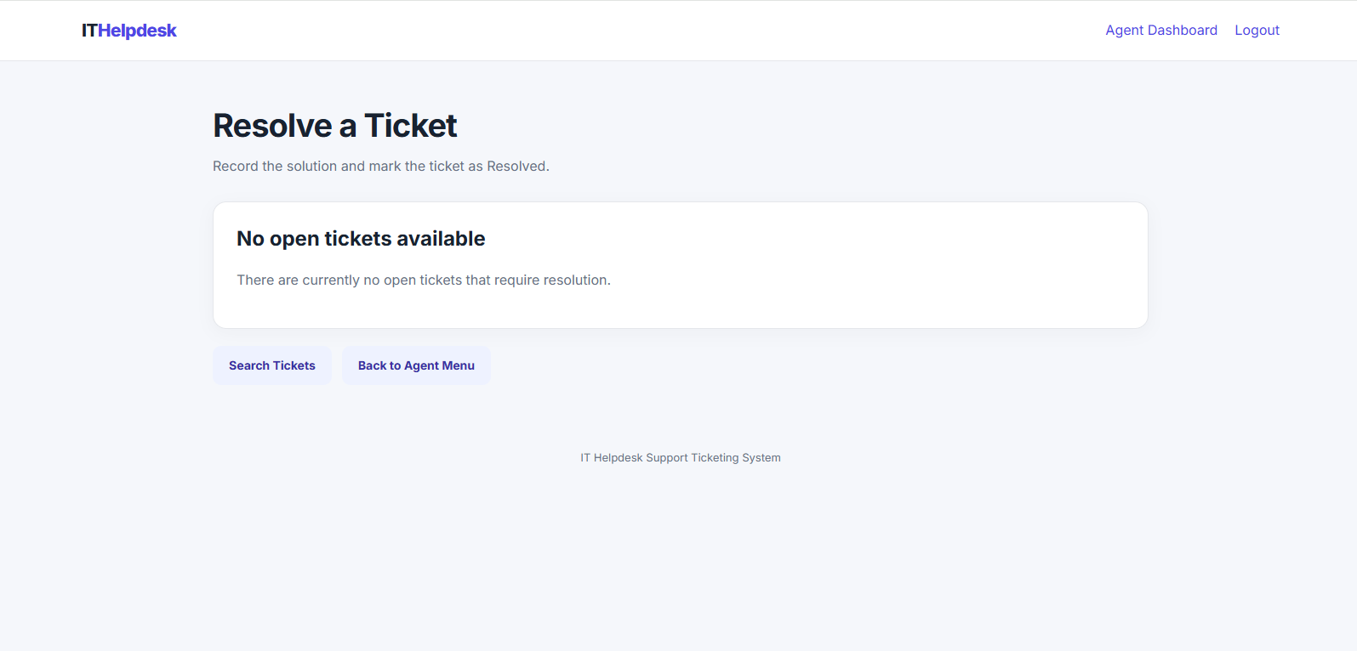

5.11 elevate_ticket.php
The Elevate a Ticket function allows support agents to escalate an unresolved IT problem to a higher support level when additional expertise is required. The system supports three levels, with agents able to select a level higher than their own, up to Level 3.
When the page loads, PHP checks that the visitor is logged in as a support agent. It retrieves the agent's current support level from the session and displays all tickets that have an Open status. The agent selects a ticket, chooses a higher support level and enters a reason explaining why the issue requires escalation.
When the form is submitted, JavaScript checks that a reason has been entered and asks the agent to confirm the action. PHP then validates the ticket ID, target support level and reason. The selected support level must be higher than the agent's current level and cannot exceed Level 3.
If the information is valid, a prepared SQL statement updates the ticket's elevated_to_level and elevation_reason fields in the tickets table. The ticket remains Open because it still requires support. A success message confirms the escalation, while an error message is displayed if the operation fails.
This function helps ensure that more complex technical problems can be passed to agents with a higher level of support expertise.
Client-Side JavaScript
JavaScript checks that the reason for escalation is not empty and asks the agent to confirm the action before submitting the form.
document.getElementById('elevateForm').addEventListener('submit', function(event) {
const reason = document.getElementById('elevation_reason').value.trim();

if (!reason) {
event.preventDefault();
alert('Please enter a reason for elevating the ticket.');
return;
}

if (!confirm('Elevate this ticket to a higher support level?')) {
event.preventDefault();
}
});
The preventDefault() function stops the form from being submitted if the reason is missing or the agent cancels the confirmation. This improves usability and helps prevent accidental submissions. PHP performs additional validation on the server because client-side checks can be bypassed.
Server-Side PHP Code
The page begins by starting the session, connecting to the database and checking that the visitor is an authenticated support agent.
session_start();
require_once 'db.php';

if (
!isset($_SESSION['agent_id']) ||
($_SESSION['role'] ?? '') !== 'agent'
) {
header('Location: agent_login.php');
exit;
}
The agent's current support level is retrieved from the session.
$currentLevel = (int) ($_SESSION['support_level'] ?? 1);
When the form is submitted, PHP retrieves the selected ticket, target support level and reason. It validates these values before attempting to update the database.
$ticketId = filter_input(INPUT_POST, 'ticket_id', FILTER_VALIDATE_INT);
$targetLevel = filter_input(INPUT_POST, 'target_level', FILTER_VALIDATE_INT);
$reason = trim($_POST['elevation_reason'] ?? '');

if (
!$ticketId ||
!$targetLevel ||
$targetLevel <= $currentLevel ||
$targetLevel > 3 ||
$reason === ''
) {
$error = 'Select a ticket, a higher support level, and provide a reason.';
}
This validation ensures that a valid ticket ID and target level are supplied, the target level is higher than the agent's current level, the target does not exceed Level 3, and a reason has been provided.
The following SQL query records the escalation.
UPDATE tickets
SET elevated_to_level = ?,
elevation_reason = ?
WHERE ticket_id = ?
AND status = 'Open';
PHP executes the prepared statement using the submitted values:
$stmt->execute([$targetLevel, $reason, $ticketId]);
The query stores the target support level and the reason for escalation while leaving the ticket status unchanged. The WHERE condition ensures that only tickets with an Open status are eligible for this operation.
If the database reports that a row has been updated, PHP displays a success message. Otherwise, it displays an error message indicating that the ticket could not be updated.
The page retrieves the available tickets using the following query:
SELECT ticket_id, subject, description, date_submitted,
elevated_to_level
FROM tickets
WHERE status = 'Open'
ORDER BY date_submitted ASC;
This displays open tickets in chronological order and identifies tickets that have previously been elevated. 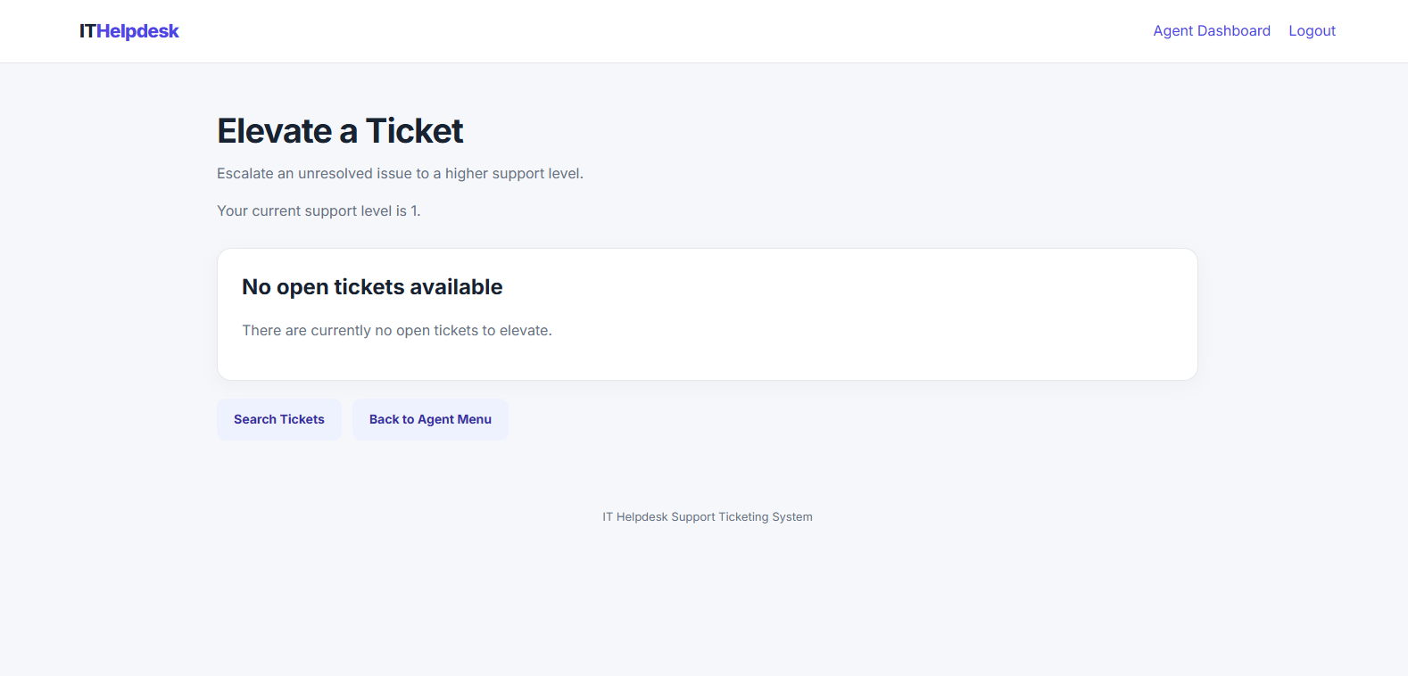

6 UX Decisions

6.1 Introduction
User Experience (UX) refers to how users interact with a website and how easy it is for them to complete tasks. When developing the IT Helpdesk Support Ticketing System, I made several design decisions to ensure the application was easy to navigate, understandable and suitable for both users and support agents.

6.2 Navigation and Layout
The application uses a consistent navigation bar to help users move between pages. The homepage provides access to user login, agent login and registration. After logging in, users and support agents are directed to separate dashboards containing the functions relevant to their roles.
The user dashboard provides options to open a ticket, view submitted tickets and close a resolved ticket. The agent dashboard provides options to search open tickets, resolve tickets and elevate tickets to a higher support level. This layout reduces confusion by separating the tasks available to each type of account.

6.3 Forms and Input Validation
Forms are used for registration, login, ticket submission, ticket resolution and ticket elevation. Each form includes labels explaining the information that must be entered.
JavaScript provides basic client-side validation before forms are submitted. For example, it checks that required fields have been completed and displays an alert if information is missing. Confirmation messages are also used before potentially important actions, such as closing, resolving or elevating a ticket.
PHP performs server-side validation as well. This is important because client-side JavaScript can be bypassed. The server checks submitted information before processing it or updating the database.

6.4 Feedback and Ticket Statuses
The system provides feedback messages to inform users whether an action has succeeded or failed. For example, registration displays a success message when an account is created, while invalid login details produce an error message.
Ticket statuses are displayed using labels to make the progress of a request easier to understand:
- Open: The ticket requires support.
- Resolved: A support agent has provided a solution.
- Closed: The user has confirmed that the issue is complete.
Users can only close tickets that have already been resolved by an agent. This prevents tickets from being closed before a solution has been provided.
6.5 Security and Access Control
Security was considered when designing the login and account management functions. Passwords are stored as hashes using PHP's password_hash() function rather than being stored as plain text. During login, password_verify() checks the entered password against the stored hash.
PHP sessions maintain the logged-in user's identity and role. User-only and agent-only pages check the session before allowing access. If an unauthorised visitor attempts to access a protected page, they are redirected to the appropriate login page.
Prepared SQL statements are used when processing database queries involving user input. Output is also escaped using htmlspecialchars() where appropriate to reduce the risk of user-provided text being interpreted as HTML.

6.6 Responsive Design and Consistency
The application uses a shared CSS stylesheet to maintain a consistent appearance across its pages. Colours, buttons, navigation elements, forms and cards follow a common design.
Responsive CSS layouts allow elements such as login pages and dashboard cards to rearrange on smaller screens. This helps maintain usability on different screen sizes, including mobile devices.

6.7 Overall UX Evaluation
The design focuses on making the main tasks straightforward and providing clear feedback throughout the ticketing process. Separate dashboards, consistent navigation, validation messages and visible ticket statuses help users understand how the system operates.
These decisions make the Support Ticketing System easier to use and help ensure that users and support agents can complete their tasks efficiently.

7. Conclusion
In conclusion, the IT Helpdesk Support Ticketing System successfully demonstrates how PHP, JavaScript and a MySQL database can be combined to create a functional web application. The system allows users to register, log in, submit support tickets, track their progress and close resolved tickets. Support agents can search open tickets, record resolutions and elevate issues to higher support levels when additional assistance is required.
The project also demonstrates the importance of database relationships, input validation, password security and session management. Docker was used to run the PHP web server, MySQL database and phpMyAdmin in separate containers, making the application easier to manage, test and inspect.
Creating the system provided practical experience in server-side processing, client-side JavaScript, database management, website design and storyboarding. Overall, the project meets its main objective of developing a structured support ticketing application while improving my understanding of how the different technologies work together to provide a functional and user-friendly website.

